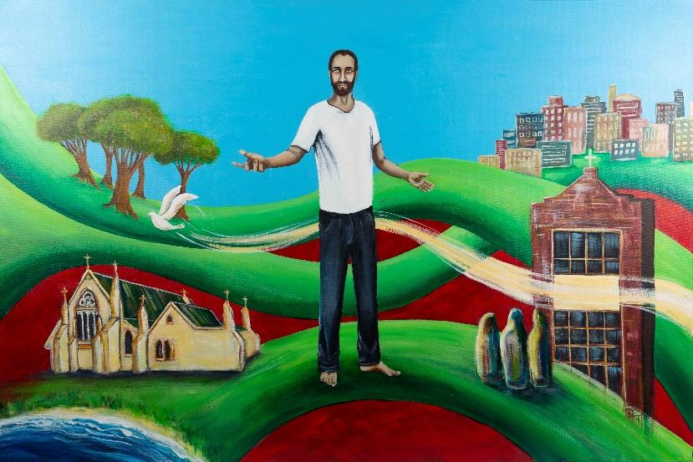

To Live in Christ Jesus
Religious Education Planning Document

Level: 1-2 | Date:  Duration: | Planning Team: | Class Teacher:

Triune God Strand
Level Foundation | Level 1 - 2 | Level 3 - 4
In the Foundation Level, students will develop the knowledge, skills and understandings to learn how to make the Sign of the Cross. They learn through this prayer that God is called Father, Son and Holy Spirit. They learn that God is experienced through the gift of creation. | In Levels 1 & 2, students will develop the knowledge, skills and understandings to learn that there are different names for God. They learn that people are precious and unique. They learn that God loves all people and wants people to love others. They continue to learn about God as the loving creator who gives life. They learn that through their senses they can experience and appreciate their world, created by God and entrusted to their care. | In Levels 3 & 4, students will develop the knowledge, skills and understandings to learn that Scripture speaks of God in many ways but most significantly for Christians as Father, Son and Holy Spirit. They learn that Christians name this understanding of God as Triune God (Trinity). They learn that people are created in God’s image and are called to live in communion with God and others. Students learn that the creation stories invite people to be responsible stewards of creation. Students learn about Jesus as the Son of God, the promised one of the Old Testament whose life, death and resurrection reveals God’s love. They learn that the Church teaches about the humanity and divinity of Jesus. They learn that they have been shown by Jesus how to live life to the full, in harmony with all creation. They learn about the variety of titles and images for the Holy Spirit and that the Holy Spirit continues to support and enliven human efforts to live according to Jesus’ teaching and ministry.
Consider appropriate Content Descriptions across the levels:
The Life and Mission of Jesus
Level Foundation | Level 1 - 2 | Level 3 - 4
In the Foundation Level, students will develop the knowledge, skills and understandings to learn about their own families and the family and life of Jesus. | In Levels 1 & 2, students will develop the knowledge, skills and understandings to learn how Jesus lived and what he taught. They learn that, guided by Jesus’ life and mission, God’s plan is for people to live in loving relationship with God, others and creation. They learn about Mary’s special role in the life of Jesus. | In Levels 3 & 4, students will develop the knowledge, skills and understandings to learn about the historical and cultural setting in which Jesus lived. They learn about the mission and ministry of Jesus that was handed on through his disciples and continues through the Church today. They learn that Mary was a woman of faith who allowed God to work through her.
Consider appropriate Content Descriptions across the levels:
Sacramental Church
Level Foundation | Level 1 - 2 | Level 3 - 4
In the Foundation Level, students will develop the knowledge, skills and understandings to enable them to learn about belonging to a family, school and Church community. They learn that people celebrate in different ways and that Catholics have particular celebrations throughout the liturgical year. Students learn that Baptism is the sacrament that welcomes people into the Church community. | In Levels 1 & 2, students will develop the knowledge, skills and understandings to enable them to learn that everyone is invited to become members of the Church community that shares God’s love. They learn about local Church communities and important liturgical celebrations in the Church. Students learn about some of the ways that people celebrate religious traditions. Students learn that sacraments are special celebrations in the life of the Church. They learn about some symbols and actions that are part of the celebration of Baptism. They learn about the Sacrament of Penance (Reconciliation). | In Levels 3 & 4, students will develop the knowledge, skills and understandings to enable them to learn that people have different experiences of life and celebrate in a variety of ways. They learn that the Church is a community of believers called to celebrate and make present the saving ministry of Jesus. They learn that the mission of Jesus continues in the Church. They learn that the Church celebrates Jesus’ life, death and resurrection in the many feasts and seasons of the liturgical year. They learn about Mary as a key figure in the Catholic Church. They learn about the Sacraments of Initiation and Healing.
Consider appropriate Content Descriptions across the levels:
Christian Life and Catholic Social Teaching
Level Foundation | Level 1 - 2 | Level 3 - 4
In the Foundation Level, students will develop the knowledge, skills and understandings to enable them to learn that they are unique and loved by their family and others. They learn about the love of God through relationships with others. | In Levels 1 & 2, students will develop the knowledge, skills and understandings to enable them to learn about their needs and the needs of others. Students learn that the love of God is expressed in the beauty of creation. They learn that God invites people to love and care for themselves, others and their world. Students recognise their own gifts and talents and explore how these can be used to help others. They learn that people’s choices and actions affect themselves, others and creation. They learn that through right relationships with others they experience the love of God. | In Levels 3 & 4, students will develop the knowledge, skills and understandings to enable them to learn that Catholic Tradition calls people to love God and to love one another. They learn that all are invited to respond to God’s love by showing care for self, others and creation. Students learn about the mission of Jesus and how personal gifts and talents can support this mission which is continued in the Church today. Students begin to learn about the principles of Catholic Social Teaching (CST), particularly focussing on the dignity of the human person, which is fundamental to how people treat themselves and others. They learn that people are called to make right choices and to take responsibility for their actions.
Consider appropriate Content Descriptions across the levels:

Scripture Lens
Level Foundation | Level 1 - 2 | Level 3 - 4
In the Foundation Level, students will develop knowledge, skills and understandings that enable them to learn some stories about Jesus from the Bible. | In Levels 1 & 2, students will develop knowledge, skills and understandings that enable them to learn that for Christians, the Bible is a sacred book that contains many stories about God: Father, Son and Holy Spirit. They learn that the Bible consists of two main sections, the Old and New Testaments. They learn some books, authors and settings in the Bible. | In Levels 3 & 4, students will develop knowledge, skills and understandings to enable them to learn that the Bible is an important collection of books written by different people over hundreds of years that witnesses to God’s saving relationship with the world. They learn that Scripture contains messages and teachings for people, past and present.
Consider appropriate Content Descriptions across the levels:
Tradition Lens
Level Foundation | Level 1 - 2 | Level 3 - 4
In the Foundation Level, students will develop the knowledge, skills and understandings to enable them to learn about families and the wider community. Students learn that the Church teaches people about Jesus. They learn that the Church is a community of people who follow Jesus. | In Levels 1 & 2, students will develop the knowledge, skills and understandings to enable them to learn how families and Church communities share experiences that help people grow in knowledge of God. | In Levels 3 & 4, students will develop the knowledge, skills and understandings to enable them to learn that Catholic Tradition is shared and celebrated through the life of the Church. They learn that people may celebrate beliefs through other religious traditions and ways of life.
Consider appropriate Content Descriptions across the levels:
Christian Prayer and Liturgy Lens
Level Foundation | Level 1 - 2 | Level 3 - 4
In the Foundation Level, students will develop the knowledge, skills and understandings to enable them to learn that through prayer people are with God in a special way. Students learn to share informal prayers and develop their knowledge of some traditional prayers. They learn some of the words, gestures and actions involved in the Mass. | In Levels 1 & 2, students will develop the knowledge, skills and understandings to enable them to learn that, like Jesus, people can have a conversation with God at any time, in any place and in many different ways. They learn that prayer involves ritual, symbol, celebration and silence, and is a way of thanking God for life and creation. They learn some of the traditional prayers of the Church and share informal prayers. They learn how to pray in different ways They learn some of the words, gestures and actions involved in the Mass. | In Levels 3 & 4, students will develop the knowledge, skills and understandings to enable them to learn how Jesus prayed and that in order to grow in relationship with God, people celebrate and pray together at different times, in different forms. They learn about the origins and significance of traditional Christian prayers and compose a variety of informal prayers. They learn how different ways of praying can be incorporated into prayer sessions. They learn that for Catholics, the celebration of the Mass is the heart of community prayer. They learn about the Mass. Students learn how the Christian community prepares for the liturgical seasons of Lent and Advent through prayer and action. They learn that Mary is honoured and celebrated through prayers, feasts and seasons of the Church’s liturgical year.
Consider appropriate Content Descriptions across the levels:

Planning for an Inquiry in RE
Personal  Preparation | - Read the Narrative.  - Read the Progression of Learning. Remember that students may sit in the levels below or above.  - Identify areas in the Level Descriptions - Strands and Lenses, that you want students to learn. Highlight these.  - Keep in mind the Church’s liturgical year and school events as these may link to your inquiry, or may not, but you have to be aware of them.  - Identify key words and phrases from what you have highlighted in the Level Descriptions. This will form the starting point for brainstorming in the next phase at the planning table.  - Identify personal learning requirements. What do I need to know to lead this inquiry?
At the Planning Table | - Share key words/themes/main points for teaching.  - Devise a starting point/statement/question which incorporates the content. Check against 5 criteria for inquiry questions - Open, Rich, Connected, Interrupting, Charged). Share ideas.  - Brainstorm ideas for the Inquiry (include possible links to RE curriculum and Scripture).  - Plan for pre-assessment.  - Consider Scripture, the AWES process, the ENTER tool and relevant resources.  - Identify personal learning requirements. What do I need to know to lead this inquiry?
Brainstorm Collaborative ideas
Pre-
Assessment Task
Scripture Text/s
Resources
Planning for my class | - Consider the findings of your pre-assessment.  - Consider what provocation will begin the inquiry (e.g., Literature, Movies, Images, Film clip, Music, News Story, Quote, Scripture, Student experiences, Explicit teaching from the curriculum, Student research).  - Consider Student Voice: What questions do students have? What connections with life do they see?  - Plan the first 2-3 sessions of your inquiry.  Keep in mind: where can the Catholic story authentically enter your inquiry?
Learning Sequence for My Class | Inquiry Question/Statement:
 | Beginning my sequence of learning:
Teacher Reflection
(WWW, EBI)
Student Feedback

