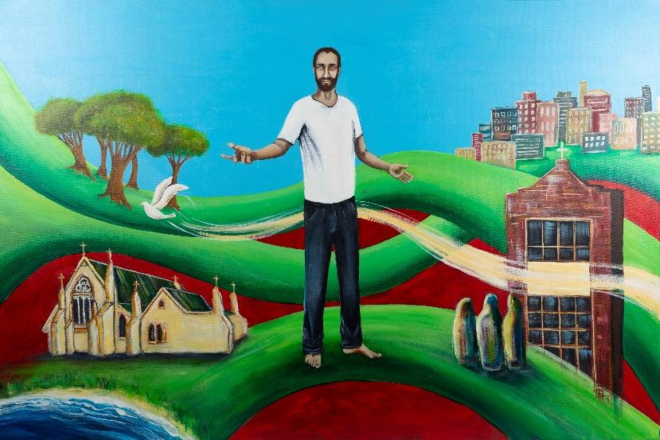

To Live in Christ Jesus
Religious Education Planning Document

Level: 5 - 6 | Date:  Duration: | Planning Team: | Class Teacher:

Triune God Strand
Level: 3 - 4 | Level: 5 - 6 | Level: 7 - 8
In Levels 3 & 4, students will develop the knowledge, skills and understandings to learn that Scripture speaks of God in many ways but most significantly for Christians as Father, Son and Holy Spirit. They learn that Christians name this understanding of God as Triune God (Trinity). They learn that people are created in God’s image and are called to live in communion with God and others. Students learn that the creation stories invite people to be responsible stewards of creation. Students learn about Jesus as the Son of God, the promised one of the Old Testament whose life, death and resurrection reveals God’s love. They learn that the Church teaches about the humanity and divinity of Jesus. They learn that they have been shown by Jesus how to live life to the full, in harmony with all creation. They learn about the variety of titles and images for the Holy Spirit and that the Holy Spirit continues to support and enliven human efforts to live according to Jesus’ teaching and ministry. | In Levels 5 & 6, students will develop the knowledge, skills and understandings to learn that Catholics recognise Jesus as both human and divine, the Son of God. They learn how Jesus, as Messiah, is the fulfilment of the Old Testament promise. They learn how Jesus’ life, death and resurrection reveal God’s love. Students learn that the Holy Spirit is the love expressed between the Father and the Son and that this is a gift freely given. They learn about the variety of images and metaphors to describe Triune God. Students learn that God, the creator of all, entrusts people with the world and with the responsibility to respect and nurture life. Students learn that the human person, created in the image of God, has dignity and natural rights, which must be considered in morally challenging situations. | In Levels 7 & 8, students will develop the knowledge, skills and understandings to enable them to learn that God reaches out to humanity in loving relationship through creation, the history of salvation in Jesus Christ, fully human and fully divine, and the mystery of human existence. They learn key aspects of the covenantal relationship God has with humanity through the Hebrew people. They learn why God sent his Son, Jesus, and describe ways God sends the Holy Spirit into the world. They learn that the Father, Son and Holy Spirit are three divine persons equal in nature and dignity who are bound together as one being, in love. They learn ways people are invited to share in the life and love of the Triune God.
Consider appropriate Content Descriptions across the levels:

The Life and Mission of Jesus
Level: 3 - 4 | Level 5 - 6 | Level 7 - 8
In Levels 3 & 4, students will develop the knowledge, skills and understandings to learn about the historical and cultural setting in which Jesus lived. They learn about the mission and ministry of Jesus that was handed on through his disciples and continues through the Church today. They learn that Mary was a woman of faith who allowed God to work through her. | In Levels 5 & 6, students will develop the knowledge, skills and understandings to learn that by responding to, and sharing in, the mission of Jesus, Christians are witnessing and proclaiming God’s unconditional love and building the Kingdom/Reign of God, which is here but not yet fully realised. Students learn about Paul and how he carried on the mission of Jesus by spreading the Word throughout the known world. Students learn that Jesus, as Messiah, is the fulfilment of the Old Testament promise. They learn that many of Jesus’ parables give an insight into the Kingdom/Reign of God. Students learn about Mary’s role as the Christian model of a faithfilled disciple. | In Levels 7 & 8, students will develop the knowledge, skills and understandings to enable them to learn about the historical, social, political and religious contexts in which Jesus lived. They learn about Jesus’ teachings, actions and mission and what they reveal about God and the Kingdom/Reign of God. Students learn practical ways the Kingdom/Reign of God can be lived out today.
Consider appropriate Content Descriptions across the levels:

Sacramental Church
Level 3 - 4 | Level 5 - 6 | Level 7-8
In Levels 3 & 4, students will develop the knowledge, skills and understandings to enable them to learn that people have different experiences of life and celebrate in a variety of ways. They learn that the Church is a community of believers called to celebrate and make present the saving ministry of Jesus. They learn that the mission of Jesus continues in the Church. They learn that the Church celebrates Jesus’ life, death and resurrection in the many feasts and seasons of the liturgical year. They learn about Mary as a key figure in the Catholic Church. They learn about the Sacraments of Initiation and Healing. | In Levels 5 & 6, students will develop the knowledge, skills and understandings to enable them to learn about the major Catholic feasts and seasons in the liturgical year. They learn that the mission of the Church is to bring about the Kingdom/Reign of God. They learn about the history of the Catholic Church in Australia. They learn that the Church honours Mary as Mother of God. They learn how the sacramental life of the Church nourishes the faith journey of its community. They learn about the gifts and fruits of the Holy Spirit and how these can be animated in people’s lives. | In Levels 7 & 8, students will develop the knowledge, skills and understandings to enable them to learn about the life and mission of the sacramental Church. They learn that sacraments express and enrich the shared life of the Christian community, celebrating initiation, healing and service and that each sacrament has its own history, symbols and rituals.
Consider appropriate Content Descriptions across the levels:

Christian Life and Catholic Social Teaching
Level 3 - 4 | Level 5 - 6 | Level 7-8
In Levels 3 & 4, students will develop the knowledge, skills and understandings to enable them to learn that Catholic Tradition calls people to love God and to love one another. They learn that all are invited to respond to God’s love by showing care for self, others and creation. Students learn about the mission of Jesus and how personal gifts and talents can support this mission which is continued in the Church today. Students begin to learn about the principles of Catholic Social Teaching (CST), particularly focussing on the dignity of the human person, which is fundamental to how people treat themselves and others. They learn that people are called to make right choices and to take responsibility for their actions. | In Levels 5 & 6, students will develop the knowledge, skills and understandings to enable them to learn about the meaning of mission and determine ways people can make a personal response now and in the future. They learn about the challenges of following the mission of Jesus today. They learn about the principles of Catholic Social Teaching (CST) drawn from the Scriptures and the moral teaching of the Church. They learn to consider local and global challenges in light of CST, and explain the impact of these challenges. | In Levels 7 & 8, students will develop the knowledge, skills and understandings to enable them to learn that the teachings, actions and mission of Jesus Christ inspire people to lead Christian lives. They learn that Christian life is nourished within a faith community, inviting people into dialogue and service. Students learn how justice calls people to be in right relationship with God, others and creation.
Consider appropriate Content Descriptions across the levels:

Scripture Lens
Level: 3 - 4 | Level 5 - 6 | Level 7 - 8
In Levels 3 & 4, students will develop knowledge, skills and understandings to enable them to learn that the Bible is an important collection of books written by different people over hundreds of years that witnesses to God’s saving relationship with the world. They learn that Scripture contains messages and teachings for people, past and present. | In Levels 5 & 6, students will develop knowledge, skills and understandings to enable them to learn about some Scripture texts that are central to Jewish and Christian faith and life. They learn that the four Gospels provide an inspired witness to the person and life of Jesus. Students learn about the similarities and differences between the four Gospels and reasons for these. They learn how to locate books and passages in the Old and New Testaments. Students learn about the different genres in Scripture. | In Levels 7 & 8, students will develop the knowledge, skills and understandings to enable them to learn that Catholics believe that the Bible is a collection of sacred books, inspired by the Holy Spirit and written in a variety of literary forms. They learn that an authentic interpretation of Scripture requires an understanding of its cultural, historical and geographical settings. Students learn that the Bible reveals God’s covenantal love through both the Old and New Testaments. They learn ways in which Scripture informs Christian Tradition and its lived expression.
Consider appropriate Content Descriptions across the levels:

Tradition Lens
Level: 3 - 4 | Level 5 - 6 | Level 7 - 8
In Levels 3 & 4, students will develop the knowledge, skills and understandings to enable them to learn that Catholic Tradition is shared and celebrated through the life of the Church. They learn that people may celebrate beliefs through other religious traditions and ways of life. | In Levels 5 & 6, students will develop the knowledge, skills and understandings to enable them to learn that Catholic Tradition has been, and continues to be, nurtured and passed on through the life of the Church. They learn some key teachings of the Church as outlined in the Nicene Creed and Apostles’ Creed. | In Levels 7 & 8, students will develop the knowledge, skills and understandings to enable them to learn about the richness of Tradition, and how, through the agency of the Holy Spirit, it helps people to make meaning of the Christian story. They learn that the life and teachings of Jesus Christ, as expressed through the lived Tradition of the Church, can inspire people to lead Christian lives.
Consider appropriate Content Descriptions across the levels:

Christian Prayer and Liturgy Lens
Level: 3 - 4 | Level 5 - 6 | Level 7 - 8
In Levels 3 & 4, students will develop the knowledge, skills and understandings to enable them to learn how Jesus prayed and that in order to grow in relationship with God, people celebrate and pray together at different times, in different forms. They learn about the origins and significance of traditional Christian prayers and compose a variety of informal prayers. They learn how different ways of praying can be incorporated into prayer sessions. They learn that for Catholics, the celebration of the Mass is the heart of community prayer. They learn about the Mass. Students learn how the Christian community prepares for the liturgical seasons of Lent and Advent through prayer and action. They learn that Mary is honoured and celebrated through prayers, feasts and seasons of the Church’s liturgical year. | In Levels 5 & 6, students will develop the knowledge, skills and understandings to enable them to learn how prayer is experienced and expressed within Christian communities and other religious traditions. They learn that Scripture is a source of inspiration and example for personal and communal prayer. They learn about the words, actions, gestures, symbols and prayers involved in liturgical celebrations. They learn that through prayer, the Holy Spirit enables people to acknowledge their sinfulness and experience the healing, reconciling power of God’s love. Students explore the origins and significance of traditional Christian prayers in the life of the Church. They learn how different ways of praying can be incorporated into classroom prayer experiences. | In Levels 7 & 8, students will develop the knowledge, skills and understandings to enable them to learn about prayer and liturgy and the importance of each to the worshipping community. Students learn about the many types and forms of Christian prayer, both personal and communal, that are part of the rich heritage of the Church.
Consider appropriate Content Descriptions across the levels:

Religion and Society Lens
Level: 3-4 | Level 5 - 6 | Level 7 - 8
 | In Levels 5 & 6, students will develop the knowledge, skills and understandings to enable them to learn how Catholics and other religious traditions celebrate and live out their core beliefs, symbols and social structures. | In Levels 7 & 8, students will develop the knowledge, skills and understandings to learn about the role religion plays in society and that religious freedom is a fundamental human right. They learn that the nature and role of religion in society is informed by faith, openness, dialogue and cultural sensitivity. Students learn about the beliefs and lived experience of Catholicism and other religions. They learn what it means to be Catholic in the contemporary world.
Consider appropriate Content Descriptions across the levels:

Planning for an Inquiry in RE
Personal  Preparation | - Read the Narrative.  - Read the Progression of Learning. Remember that students may sit in the levels below or above.  - Identify areas in the Level Descriptions - Strands and Lenses, that you want students to learn. Highlight these.  - Keep in mind the Church’s liturgical year and school events as these may link to your inquiry, or may not, but you have to be aware of them.  - Identify key words and phrases from what you have highlighted in the Level Descriptions. This will form the starting point for brainstorming in the next phase at the planning table.  - Identify personal learning requirements. What do I need to know to lead this inquiry?
At the Planning Table | - Share key words/themes/main points for teaching.  - Devise a starting point/statement/question which incorporates the content. Check against 5 criteria for inquiry questions - Open, Rich, Connected, Interrupting, Charged). Share ideas.  - Brainstorm ideas for the Inquiry (include possible links to RE curriculum and Scripture).  - Plan for pre-assessment.  - Consider Scripture, the AWES process, the ENTER tool and relevant resources.  - Identify personal learning requirements. What do I need to know to lead this inquiry?
Brainstorm Collaborative ideas
Pre-
Assessment Task
Scripture Text/s
Resources
Planning for my class | - Consider the findings of your pre-assessment.  - Consider what provocation will begin the inquiry (e.g., Literature, Movies, Images, Film clip, Music, News Story, Quote, Scripture, Student experiences, Explicit teaching from the curriculum, Student research).  - Consider Student Voice: What questions do students have? What connections with life do they see?  - Plan the first 2-3 sessions of your inquiry.  Keep in mind: where can the Catholic story authentically enter your inquiry?
Learning Sequence for My Class | Inquiry Question/Statement:
 | Beginning my sequence of learning:
Teacher Reflection
(WWW, EBI)
Student Feedback

