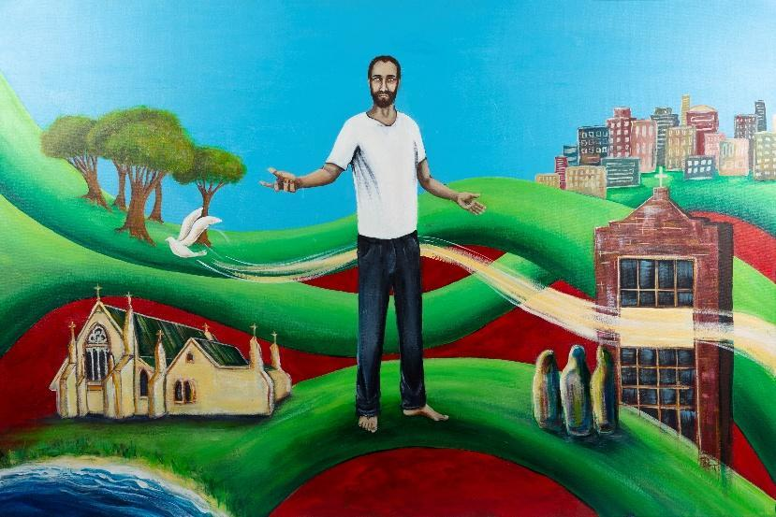

To Live in Christ Jesus
Religious Education Planning Document

Level: 7 - 8 | Date:  Duration: | Planning Team: | Class Teacher:

Triune God Strand
Level: 5 - 6 | Level: 7 - 8 | Level: 9 - 10
In Levels 5 & 6, students will develop the knowledge, skills and understandings to learn that Catholics recognise Jesus as both human and divine, the Son of God. They learn how Jesus, as Messiah, is the fulfilment of the Old Testament promise. They learn how Jesus’ life, death and resurrection reveal God’s love. Students learn that the Holy Spirit is the love expressed between the Father and the Son and that this is a gift freely given. They learn about the variety of images and metaphors to describe Triune God. Students learn that God, the creator of all, entrusts people with the world and with the responsibility to respect and nurture life. Students learn that the human person, created in the image of God, has dignity and natural rights, which must be considered in morally challenging situations. | In Levels 7 & 8, students will develop the knowledge, skills and understandings to enable them to learn that God reaches out to humanity in loving relationship through creation, the history of salvation in Jesus Christ, fully human and fully divine, and the mystery of human existence. They learn key aspects of the covenantal relationship God has with humanity through the Hebrew people. They learn why God sent his Son, Jesus, and describe ways God sends the Holy Spirit into the world. They learn that the Father, Son and Holy Spirit are three divine persons equal in nature and dignity who are bound together as one being, in love. They learn ways people are invited to share in the life and love of the Triune God. | In Levels 9 & 10, students will develop the knowledge, skills and understandings to enable them to learn how people experience God’s lifegiving grace through the Incarnation, the Holy Spirit, the Church and creation. Students learn about the Christian call to stewardship. They learn that the Catholic doctrine of the Triune God expresses an understanding of God as love. They learn about the ways Christians give witness to the Triune God by creating loving communities where the dignity of the human person is respected.
Consider Content Descriptions across the levels:

The Life and Mission of Jesus
Level: 5 - 6 | Level 7 - 8 | Level 9 - 10
In Levels 5 & 6, students will develop the knowledge, skills and understandings to learn that by responding to, and sharing in, the mission of Jesus, Christians are witnessing and proclaiming God’s unconditional love and building the Kingdom/Reign of God, which is here but not yet fully realised. Students learn about Paul and how he carried on the mission of Jesus by spreading the Word throughout the known world. Students learn that Jesus, as Messiah, is the fulfilment of the Old Testament promise. They learn that many of Jesus’ parables give an insight into the Kingdom/Reign of God. Students learn about Mary’s role as the Christian model of a faithfilled disciple. | In Levels 7 & 8, students will develop the knowledge, skills and understandings to enable them to learn about the historical, social, political and religious contexts in which Jesus lived. They learn about Jesus’ teachings, actions and mission and what they reveal about God and the Kingdom/Reign of God. Students learn practical ways the Kingdom/Reign of God can be lived out today. | In Levels 9 & 10, students will develop the knowledge, skills and understandings to enable them to learn about the portrayal of Jesus through the Gospels. They learn about the central Christian belief in the resurrection of Jesus as the foundation for Christian hope. Through a study of Church teachings on death and eternal life, students learn how, for Christians, death has been transformed by Jesus.
Consider Content Descriptions across the levels:

Sacramental Church
Level 5 - 6 | Level 7-8 | Level 9 - 10
In Levels 5 & 6, students will develop the knowledge, skills and understandings to enable them to learn about the major Catholic feasts and seasons in the liturgical year. They learn that the mission of the Church is to bring about the Kingdom/Reign of God. They learn about the history of the Catholic Church in Australia. They learn that the Church honours Mary as Mother of God. They learn how the sacramental life of the Church nourishes the faith journey of its community. They learn about the gifts and fruits of the Holy Spirit and how these can be animated in people’s lives. | In Levels 7 & 8, students will develop the knowledge, skills and understandings to enable them to learn about the life and mission of the sacramental Church. They learn that sacraments express and enrich the shared life of the Christian community, celebrating initiation, healing and service and that each sacrament has its own history, symbols and rituals. | In Levels 9 & 10, students will develop the knowledge, skills and understandings to enable them to learn how the Catholic Church worships and celebrates as a sacramental community. They learn about the ongoing renewal of the Catholic Church, both locally and globally, and the call to service that is implicit in the Sacrament of the Eucharist, the source and summit of Christian life. They learn that the Church is called into dialogue with other Christian traditions and religions of the world.
Consider Content Descriptions across the levels:

Christian Life and Catholic Social Teaching
Level 5 - 6 | Level 7 - 8 | Level 9 - 10
In Levels 5 & 6, students will develop the knowledge, skills and understandings to enable them to learn about the meaning of mission and determine ways people can make a personal response now and in the future. They learn about the challenges of following the mission of Jesus today. They learn about the principles of Catholic Social Teaching (CST) drawn from the Scriptures and the moral teaching of the Church. They learn to consider local and global challenges in light of CST, and explain the impact of these challenges. | In Levels 7 & 8, students will develop the knowledge, skills and understandings to enable them to learn that the teachings, actions and mission of Jesus Christ inspire people to lead Christian lives. They learn that Christian life is nourished within a faith community, inviting people into dialogue and service. Students learn how justice calls people to be in right relationship with God, others and creation. | In Levels 9 & 10, students will develop the knowledge, skills and understandings to enable them to learn that Christian life challenges Catholics to share in the mission of Christ as disciples. They learn that the Christian understanding of the dignity of the human person requires the pursuit of the common good in a spirit of solidarity. Students learn how Christian life calls people to an understanding of the Church’s moral and ethical teachings and can identify the role of conscience in moral decisionmaking. They learn how inspirational figures in Catholic Tradition encourage a Christian thirst for justice.
Consider Content Descriptions across the levels:

Scripture Lens
Level: 5 - 6 | Level 7 - 8 | Level 9 - 10
In Levels 5 & 6, students will develop knowledge, skills and understandings to enable them to learn about some Scripture texts that are central to Jewish and Christian faith and life. They learn that the four Gospels provide an inspired witness to the person and life of Jesus. Students learn about the similarities and differences between the four Gospels and reasons for these. They learn how to locate books and passages in the Old and New Testaments. Students learn about the different genres in Scripture. | In Levels 7 & 8, students will develop the knowledge, skills and understandings to enable them to learn that Catholics believe that the Bible is a collection of sacred books, inspired by the Holy Spirit and written in a variety of literary forms. They learn that an authentic interpretation of Scripture requires an understanding of its cultural, historical and geographical settings. Students learn that the Bible reveals God’s covenantal love through both the Old and New Testaments. They learn ways in which Scripture informs Christian Tradition and its lived expression. | In Levels 9 & 10, students will develop the knowledge, skills and understandings to enable them to learn how Scriptural context influences the study, understanding and lived expression of Scripture. Students learn stories of Old Testament prophets, where people are called back to the covenantal relationship with God. They learn ways that believers are nourished by Scripture and how they are called to make a positive impact in the world. They learn ways in which Scripture informs Christian Tradition and its lived expression.
Consider Content Descriptions across the levels:

Tradition Lens
Level 5 - 6 | Level 7 - 8 | Level 9 - 10
In Levels 5 & 6, students will develop the knowledge, skills and understandings to enable them to learn that Catholic Tradition has been, and continues to be, nurtured and passed on through the life of the Church. They learn some key teachings of the Church as outlined in the Nicene Creed and Apostles’ Creed. | In Levels 7 & 8, students will develop the knowledge, skills and understandings to enable them to learn about the richness of Tradition, and how, through the agency of the Holy Spirit, it helps people to make meaning of the Christian story. They learn that the life and teachings of Jesus Christ, as expressed through the lived Tradition of the Church, can inspire people to lead Christian lives. | In Levels 9 & 10, students will develop the knowledge, skills and understandings to enable them to learn that Tradition is the transmission of the message of Christ and this can occur in many different ways, thus promoting the ongoing renewal and unity of the Church. They learn that there are truths that Catholics believe and hold in common. Students learn that being a member of the Church invites a response to accept the wisdom of the faith community, expressed through Tradition.
Consider Content Descriptions across the levels:

Christian Prayer and Liturgy Lens
Level 5 - 6 | Level 7 - 8 | Level 9 - 10
In Levels 5 & 6, students will develop the knowledge, skills and understandings to enable them to learn how prayer is experienced and expressed within Christian communities and other religious traditions. They learn that Scripture is a source of inspiration and example for personal and communal prayer. They learn about the words, actions, gestures, symbols and prayers involved in liturgical celebrations. They learn that through prayer, the Holy Spirit enables people to acknowledge their sinfulness and experience the healing, reconciling power of God’s love. Students explore the origins and significance of traditional Christian prayers in the life of the Church. They learn how different ways of praying can be incorporated into classroom prayer experiences. | In Levels 7 & 8, students will develop the knowledge, skills and understandings to enable them to learn about prayer and liturgy and the importance of each to the worshipping community. Students learn about the many types and forms of Christian prayer, both personal and communal, that are part of the rich heritage of the Church. | In Levels 9 & 10, students will develop the knowledge, skills and understandings to enable them to learn how prayer is an expression of people’s relationship with God and that prayer and liturgy are each central to the life and mission of the Church. They learn that prayer and reflection can support wise decision-making.
Consider Content Descriptions across the levels:

Religion and Society Lens
Level 5 - 6 | Level 7 - 8 | Level 9 - 10
In Levels 5 & 6, students will develop the knowledge, skills and understandings to enable them to learn how Catholics and other religious traditions celebrate and live out their core beliefs, symbols and social structures. | In Levels 7 & 8, students will develop the knowledge, skills and understandings to learn about the role religion plays in society and that religious freedom is a fundamental human right. They learn that the nature and role of religion in society is informed by faith, openness, dialogue and cultural sensitivity. Students learn about the beliefs and lived experience of Catholicism and other religions. They learn what it means to be Catholic in the contemporary world. | In Levels 9 & 10, students will develop the knowledge, skills and understandings to enable them to learn that religious perspective can influence personal and communal code of ethics and morality. They learn how a person’s religious community, society and other factors shape the development of personal spirituality and moral code. They learn the importance of ecumenism in developing Christian unity through dialogue. They learn how Aboriginal and Torres Strait Islander spiritualities contribute to the development of an Australian spirituality.
Consider Content Descriptions across the levels:

Planning for an Inquiry in RE
Personal  Preparation | - Read the Narrative.  - Read the Progression of Learning. Remember that students may sit in the levels below or above.  - Identify areas in the Level Descriptions - Strands and Lenses, that you want students to learn. Highlight these.  - Keep in mind the Church’s liturgical year and school events as these may link to your inquiry, or may not, but you have to be aware of them.  - Identify key words and phrases from what you have highlighted in the Level Descriptions. This will form the starting point for brainstorming in the next phase at the planning table.  - Identify personal learning requirements. What do I need to know to lead this inquiry?
At the Planning Table | - Share key words/themes/main points for teaching.  - Devise a starting point/statement/question which incorporates the content. Check against 5 criteria for inquiry questions - Open, Rich, Connected, Interrupting, Charged). Share ideas.  - Brainstorm ideas for the Inquiry (include possible links to RE curriculum and Scripture).  - Plan for pre-assessment.  - Consider Scripture, the AWES process, the ENTER tool and relevant resources.  - Identify personal learning requirements. What do I need to know to lead this inquiry?
Brainstorm Collaborative ideas
Pre-
Assessment Task
Scripture Text/s
Resources
Planning for my class | - Consider the findings of your pre-assessment.  - Consider what provocation will begin the inquiry (e.g., Literature, Movies, Images, Film clip, Music, News Story, Quote, Scripture, Student experiences, Explicit teaching from the curriculum, Student research).  - Consider Student Voice: What questions do students have? What connections with life do they see?  - Plan the first 2-3 sessions of your inquiry.  Keep in mind: where can the Catholic story authentically enter your inquiry?
Learning Sequence for My Class | Inquiry Question/Statement:
 | Beginning my sequence of learning:
Teacher Reflection
(WWW, EBI)
Student Feedback

